5. Resource allocation and responsibility matrix
The project is delivered by a core team of 6 roles (the four student group members take the first four), supported by client staff, the vendor and an integration partner. Allocation is highest in the build and test phases, from April to July 2027.
5.1 Project roles and allocation
Role | Filled by | Key responsibilities | Allocation
Project Manager (PM) | Group member 1 | Plan, schedule, budget, risks, issues, change control, reporting | 100%, whole project
IAM Architect | Group member 2 | Architecture, role model, SSO and MFA design, vendor evaluation | 100%, Feb to Jul; 50% Aug to Sep
Integration and Test Lead | Group member 3 | Provisioning, application integrations, SIT and UAT coordination, cut-over | 100%, Apr to Sep
Change, Comms and Configuration Lead | Group member 4 | Training, communications, GitHub repository, document control | 50% Feb to Jun; 100% Jul to Sep
Security Analyst (client) | CCU cyber team | CPS 234 gap analysis, PAM vault, pen test coordination | 60%, Feb to Jul
Integration engineers (2) | Integration partner | Configuration and connector build in Phase 3 sprints | 100%, Apr to Jul
Project sponsor | CIO | Funding, gate approvals, escalations | About 2 hours per week
HR systems lead | CCU HR | HR data clean-up, provisioning workflow design, UAT | 20%, Feb to Jun
Service desk manager | CCU IT operations | Support model, runbooks, hypercare roster | 20% Jun to Sep
5.2 Other resources
- Cloud IAM tenancy (production + test) located within Australian region, licensed to support 750 identities.
- 600 FIDO2 tokens (500 staff + 100 spares/admin). Remaining staff use authenticator app.
- External CREST accredited penetration testing company (10 days).
- GitHub Team for repository management. Projects board, issues and pull requests.
- Training room available at Head Office and e-learning module on current learning platform.
- 5.3 RACI matrix
R = Responsible (does the work), A = Accountable (one per row, signs off), C = Consulted, I = Informed. Column headings are short forms: Architect = IAM Architect, Test Lead = Integration and Test Lead, Config Lead = Change, Comms and Config Lead, Security = Security Analyst, HR = HR systems lead, Desk = Service desk manager.
Work package | Sponsor | PM | Architect | Test Lead | Config Lead | Security | HR | Desk
1.1 Project charter | A | R | C | C | C | C | I | I
1.2 Stakeholder analysis | I | A/R | C | C | R | C | C | C
2.1 Identity audit | I | A | R | C | I | R | C | C
2.2 Requirements and CPS 234 gaps | I | A | C | C | I | R | C | C
2.3 Vendor selection | A | R | R | C | I | C | I | I
2.4 Architecture and role model | I | C | A/R | C | I | C | C | I
3.2 HR-driven provisioning | I | C | C | A/R | I | I | R | I
3.3 SSO and MFA | I | C | A/R | R | I | C | I | C
3.4 PAM vault | I | C | C | C | I | A/R | I | I
3.5 Application integrations | I | C | C | A/R | I | C | I | I
4.1–4.3 Testing | I | A | C | R | I | R | R | C
M2 Go-live approval | A | R | C | C | C | C | I | C
5.1–5.3 Pilot, training, rollout | I | A | C | R | R | I | I | R
5.4 Legacy shutdown | I | A | C | R | I | C | I | I
6.1–6.2 Hypercare and handover | I | A | C | R | C | I | I | R
6.3 Closure report | A | R | C | C | C | C | I | I
GitHub configuration management | I | A | C | C | R | I | I | I
5.4 Resource levelling
The IAM Architect is over-loaded during Sprint 1 (20 April – 4 May) due to the overlapping activities within SSO and MFA (3.3) and Provisioning Support Design. The PAM Vault (3.4) task has 20 days of float, therefore the Security Analyst will lead on this task with the architect providing consultancy support. The SSO task will consume 2 of the 5 float days if necessary. No Critical Path activities are being moved.
6. Risk Identification, Analysis & Mitigation
There were 12 risks identified. Of which 9 were High risk. The most significant risks were poor data quality in HR (R2) and integrating with core banking (R1). These risks are managed using the enterprise risk management framework provided by CCU. This follows the ISO 31000 standard (ISO, 2018).6.1 Risk management process
- Identify – risk workshops at kick-off and at each phase gate, plus any team member raising a risk as a GitHub issue labelled risk.
- Analyse – score likelihood and impact from 1 to 5; score = L × I. Impact considers schedule, cost, security and member service.
- Evaluate – Low (1–4) accept and monitor; Medium (5–9) mitigate within the team; High (10–16) mitigation plan with a named owner, reported to steering committee; Extreme (20–25) escalate to sponsor within 24 hours.
- Respond – choose a strategy: avoid, mitigate, transfer or accept; assign an owner and a trigger.
- Monitor – the register is reviewed weekly by the PM and monthly by the steering committee; closed risks are kept for lessons learned.
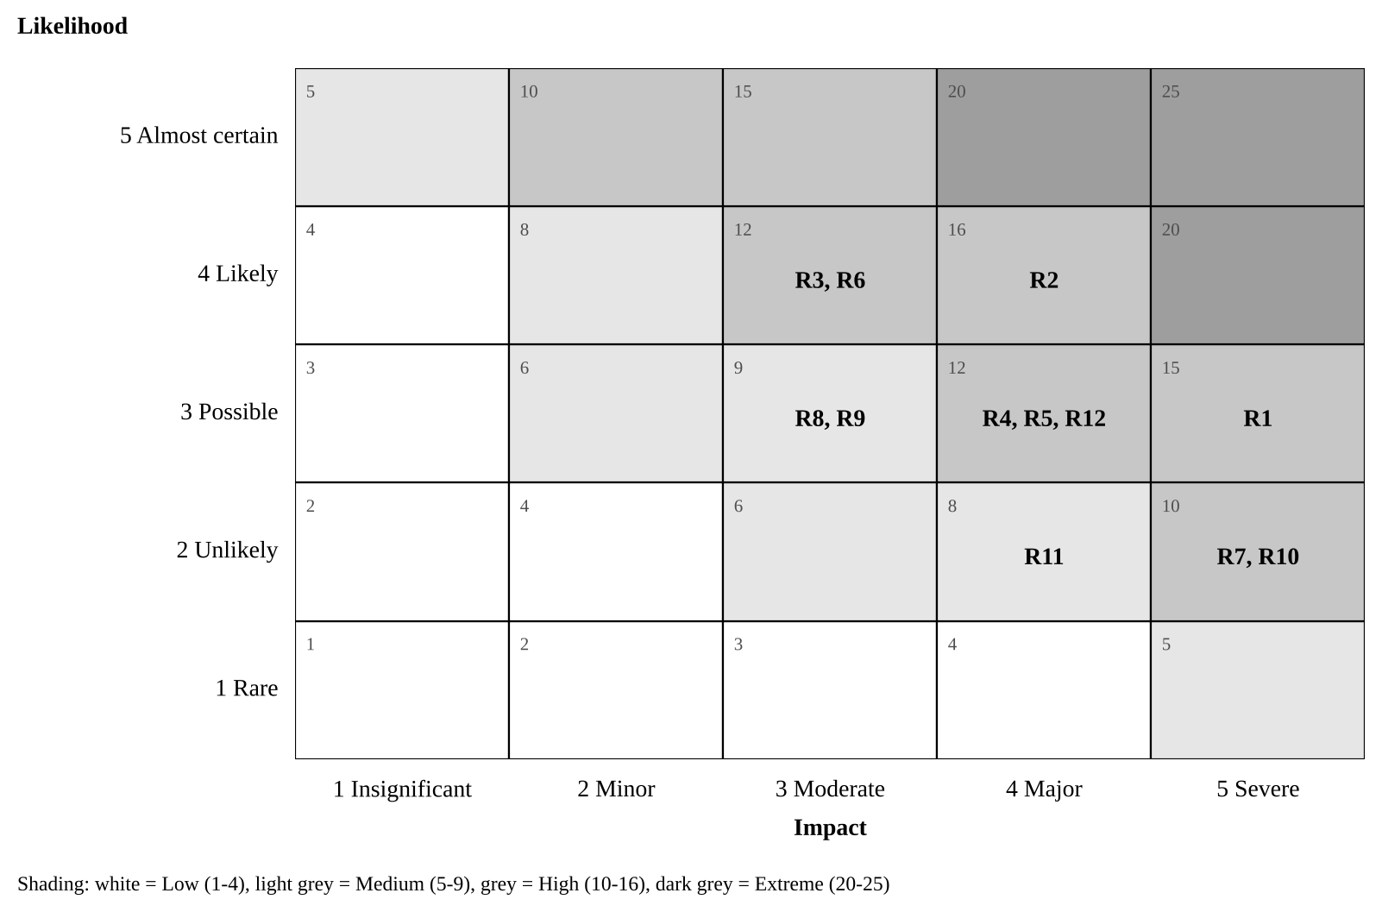
Figure 3: Risk matrix showing inherent risk of the 12 identified risks
6.2 Risk register
ID | Risk (cause → effect) | Score (L × I) | Strategy | Mitigation, contingency and trigger | Owner
R1 | Core banking supports only legacy authentication → SSO cannot be applied to the highest-risk system | 3 × 5 = 15 High | Mitigate | Core banking SSO must be shown in the vendor proof of concept (2.3); fallback is an access gateway with MFA in front of core banking. Trigger: PoC fails the core banking scenario. | IAM Architect
R2 | HR records are inaccurate or incomplete → wrong access granted or leavers missed | 4 × 4 = 16 High | Mitigate | Data clean-up during audit (2.1); run provisioning in report-only mode for 2 weeks and reconcile daily before enforcing. Trigger: Reconciliation error rate above 2%. | HR systems lead
R3 | Staff find MFA unfamiliar → lockouts and slower member service in branches | 4 × 3 = 12 High | Mitigate | Pilot first, 15-minute e-learning, branch floor-walkers on go-live days, self-service recovery. Trigger: Lockout tickets above 30 per day. | Change, Comms and Config Lead
R4 | Key client staff are pulled into BAU work → design and testing delays | 3 × 4 = 12 High | Mitigate | Backfill budget (AUD 170,000); named deputies; time commitments agreed in charter. Trigger: Two missed workshops in a row. | PM
R5 | Pen test finds critical issues late → go-live postponed | 3 × 4 = 12 High | Mitigate | Security design review at M1; configuration scanning during build; 5 days float on 4.2. Trigger: Any critical finding open at 30 June. | Security Analyst
R6 | Business units request extra applications → scope creep | 4 × 3 = 12 High | Avoid | Strict change control (Section 8); extra applications go to a Phase 2 backlog. Trigger: Change requests that add applications. | PM
R7 | Break-glass or admin access lost during PAM cut-over → systems cannot be administered | 2 × 5 = 10 High | Mitigate | Two sealed break-glass accounts tested before cut-over; staged onboarding by system; rollback plan. Trigger: Failed break-glass test. | Security Analyst
R8 | Licence procurement or vendor resourcing slips → build starts late | 3 × 3 = 9 Medium | Transfer | Contract with delivery milestones and penalties; purchase order raised during 2.3. Trigger: Contract not signed by 18 Mar. | PM
R9 | Integrations need more effort than estimated → cost overrun | 3 × 3 = 9 Medium | Transfer, mitigate | Fixed-price statement of work for the 12 integrations; 10% contingency held by sponsor. Trigger: Earned value CPI below 0.95. | PM
R10 | Cloud IdP outage → staff cannot log in to any system | 2 × 5 = 10 High | Mitigate | 99.9% availability SLA; cached credentials and offline MFA for core banking; outage runbook in BCP (APRA, 2023). Trigger: Vendor incident alert. | Integration and Test Lead
R11 | Identity data stored offshore or over-collected → privacy or contractual breach | 2 × 4 = 8 Medium | Avoid | Australian region written into contract; privacy impact assessment before build. Trigger: PIA raises a high finding. | Security Analyst
R12 | Attackers send repeated MFA prompts during rollout → account takeover | 3 × 4 = 12 High | Mitigate | Number matching and FIDO2 keys for admins; rate limiting; awareness message in every rollout email. Trigger: Unusual MFA denial spikes. | Security Analyst
After mitigation, every High risk is expected to fall to Medium or Low; residual scores are re-assessed at each gate and recorded in the register on GitHub.
7. Issue management strategy
Issues are problems that are currently impacting the project. All issues are created in GitHub as an issue with a priority and owner within 1 business day. They are tracked on the project board until they are closed.
7.1 Issue lifecycle
- Raise: Any member of the team will raise an issue using the issue report template to describe the problem, impact, when it was identified and which work packages were affected.
- Triage: New issues are reviewed by the PM on a daily basis. They will prioritise, assign owners and identify a resolution date.
- Analyse: Owner will analyse the issue to identify the root cause and possible solutions. This will be documented in the issue thread.
- Resolve: The solution will be implemented. If the corrective action impacts scope/schedule/cost, then the owner will raise a change request (see section 8) and link this into the issue.
- Verify & Close: The raiser will confirm the issue has been resolved. PM will close the issue and document any lessons learned..
7.2 Priority and escalation
Priority | Definition | Target resolution | Escalation path
P1 Critical | Blocks a critical-path activity, causes a security exposure or affects member service | 1 business day | PM informs sponsor and CISO immediately
P2 High | Delays a non-critical activity by more than its float, or affects a milestone | 3 business days | PM reports at weekly steering update
P3 Medium | Workaround exists; no milestone impact | 10 business days | Managed within the team
P4 Low | Minor or cosmetic | Next sprint or backlog | Managed within the team
An unresolved issue escalates one level when it passes its target date. Issues that turn out to be recurring are added to the risk register as risks for the rest of the project.
7.3 Issue log (GitHub)
Issue Log – This is used in GitHub by using the filtered view label:issue. This provides information such as Issue ID, Title, Priority, Owner, Status (Open, In progress, Blocked, Resolved, Closed), Date Raised, Target Date and Change Request. The PM will provide an overview of how many P1/P2 Issues are currently open and the average age of open Issues. Issue Log template can be found in appendix B.
7.4 Example issues
ID | Issue | Priority | Owner | Action
I-01 | HR system API rate limit stops full identity sync in test | P2 | Integration and Test Lead | Vendor raises limit; sync batched overnight
I-02 | Two branches have no FIDO2-compatible USB ports on teller PCs | P2 | Change, Comms and Config Lead | Those tellers use the authenticator app; PCs listed for refresh
I-03 | UAT testers from lending unavailable in week 1 of UAT | P3 | PM | Lending scripts moved to week 2; within float
8. Change request and change management process
No changes are made to the approved scope, schedule baseline, budget, or design. Any changes must be approved via approved change requests (CR). Minor changes (2 working days or less schedule impact to non-critical activities, or AUD 10,000) can be approved by the PM. Anything larger, or relating to critical path, security controls or milestones will be escalated to the Change Control Board (CCB).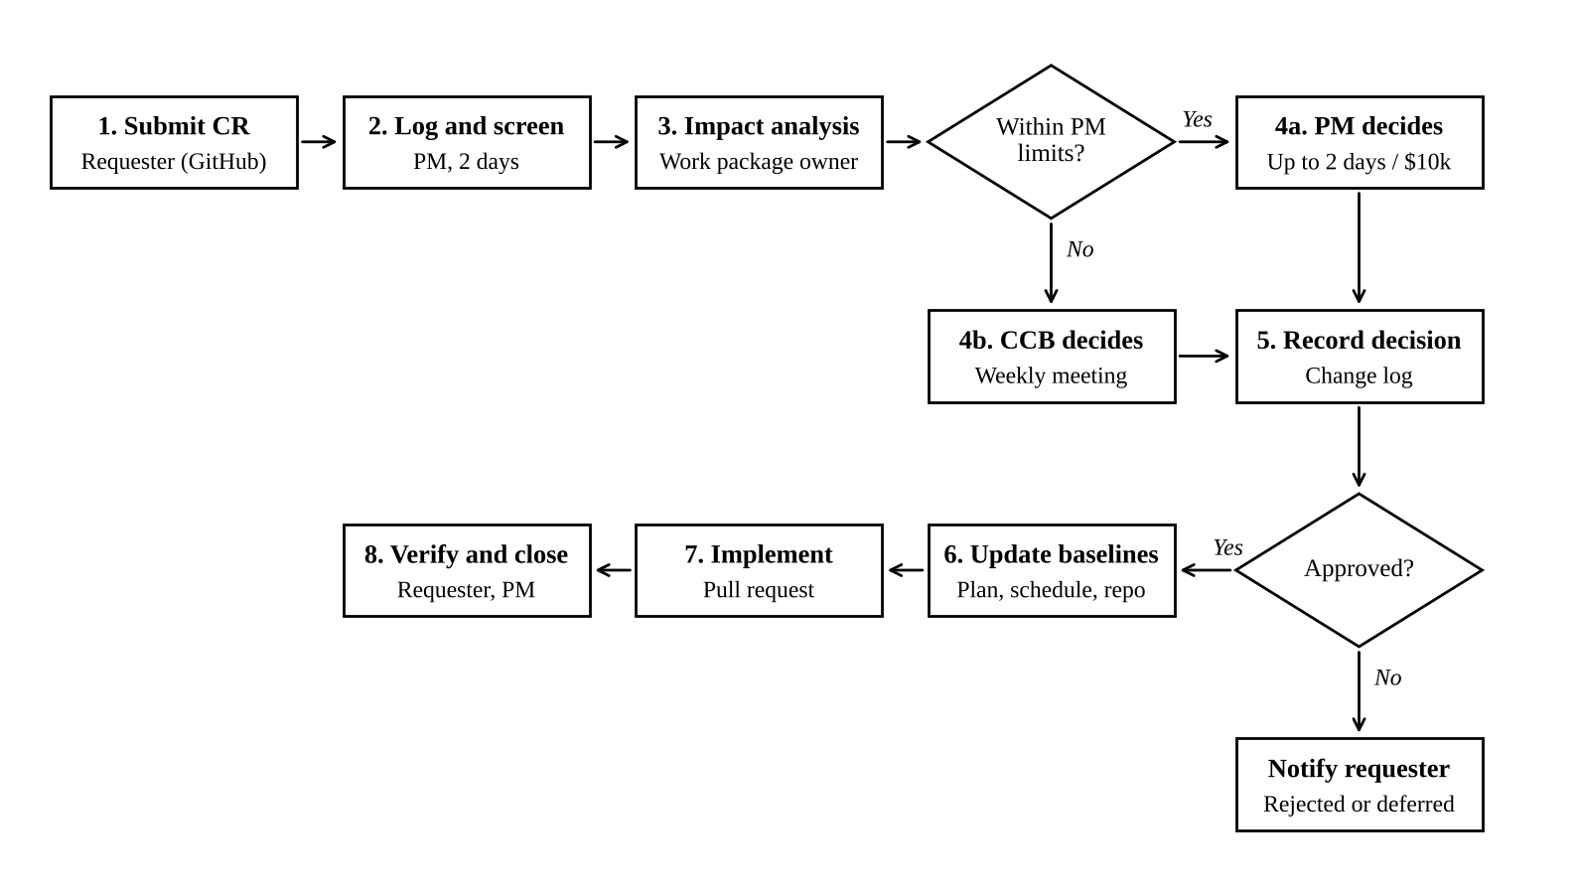
Figure 4: Change request process flow
8.1 Process steps
1.Submit – The change requestor will create a GitHub issue using the Change request template (Appendix A). They will include what, why, the urgency and benefit of the change.
2.Log and Screen – Within 2 business days the PM will assign a CR number, ensure that there is everything required and any duplicate or out of scope ideas rejected. These will be placed into the Phase 2 backlog.
3.Impact analysis – The work package owner will carry out an impact analysis looking at how the change will affect the scope, schedule (including critical path and float), cost, quality, risk, security and compliance. This will be completed within 5 business days.
4.Decide – Any changes that fall under delegated authority will be decided by the PM. If they do not then they will be passed onto the weekly CCB. This can result in approval, rejection, deferring or asking for further information.
5.Record – The decision will be recorded in the CR issue along with any conditions attached to it and who approved it.
6.Baseline Updates – The PM will update the schedule, budget, risk register and relevant documents if the CR has been approved. All document changes are done via a pull request to keep a historical record in the repo.
7.Implement and Verify – The change will be implemented and tested. It will be confirmed by the change requestor that the change met their needs and closed by the PM.
8.Communicate – Any changes that have been approved will be summarised in the weekly status report. Any rejected or deferred changes will be explained to the change requestor.
8.2 Change Control Board
Member | Role on CCB
CIO (sponsor) | Chair; final decision on budget and milestone changes
CISO | Approves any change to security controls or risk acceptance
Project Manager | Presents impact analysis; secretary
IAM Architect | Technical and design impact
Operations manager | BAU and service impact
The CCB will meet every week as part of the project (on a Wednesday for 30 mins) and can be called within 24 hrs if there are any urgent changes to approve. The minimum number of people required for the meeting is the Chair, CISO and PM. Any changes to production that have been approved by the CCB still need to go through the CCU IT Change Advisory Board (CAB). This means that there is a link between project change control and operational change control.
8.3 Change classification
Class | Example | Approver | Target decision time
Minor | Reword a training guide; move a non-critical task within its float | PM | 2 business days
Major | Add an application to SSO scope; use contingency; change a milestone | CCB | Next weekly CCB
Emergency | Urgent fix to a security weakness found in testing | CCB chair and CISO | 24 hours, ratified at next CCB
8.4 Organisational change management
Due to the different login processes, the change management for this will be handled via the ADKAR model (Hiatt, 2006). This includes: Awareness (the message from the CEO and articles on the Intranet from May); Desire (stories about why MFA is protecting our members); Knowledge (via e-learning and quick reference guides); Ability (Pilots, floor walkers and a practice environment); and Reinforcement (Dashboard showing how many people have signed up to MFA per branch and early adopter recognition).

